Challenges 2
- Resolve Merge conflicts: A merge conflict occurs when git cannot automatically merge changes.
-Create a merge conflict intentionally (two users editing the same line).
created a file in branch and switched branch
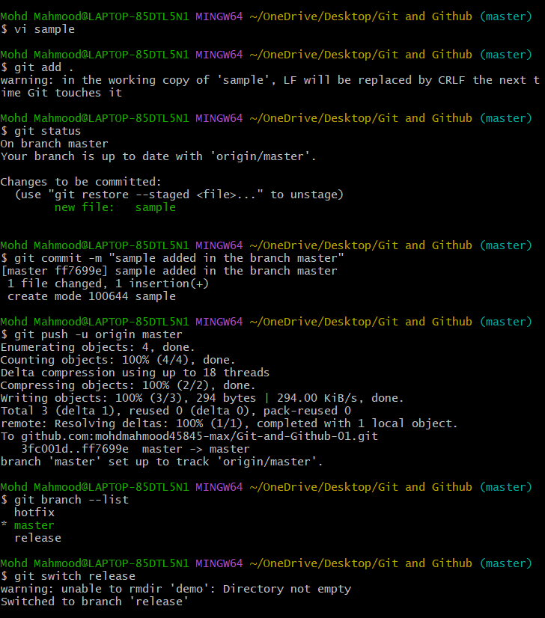
created a same file in another branch and merged it
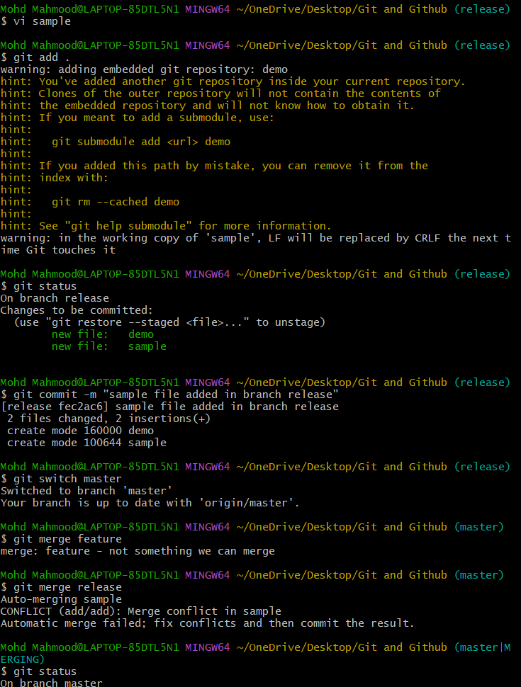
Final output of the merge file
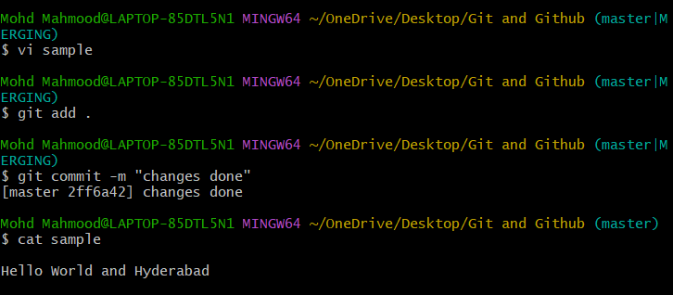
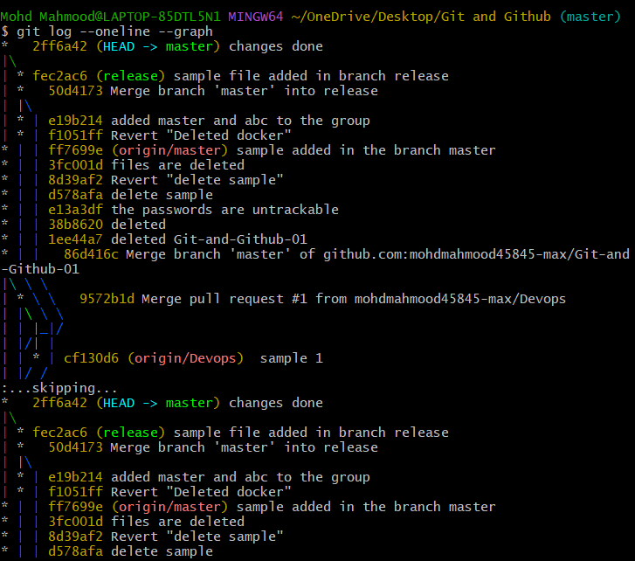
- Resolve the conflict and push the changes
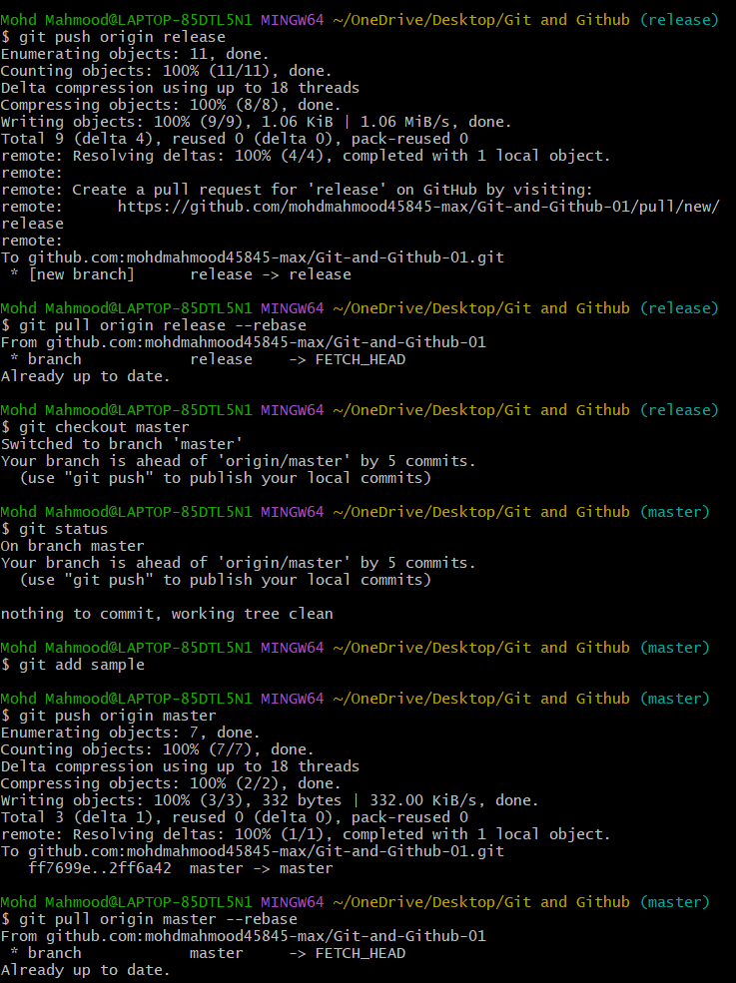
- Recover a Deleted Branch
First delete the branch and recover the branch with commit id
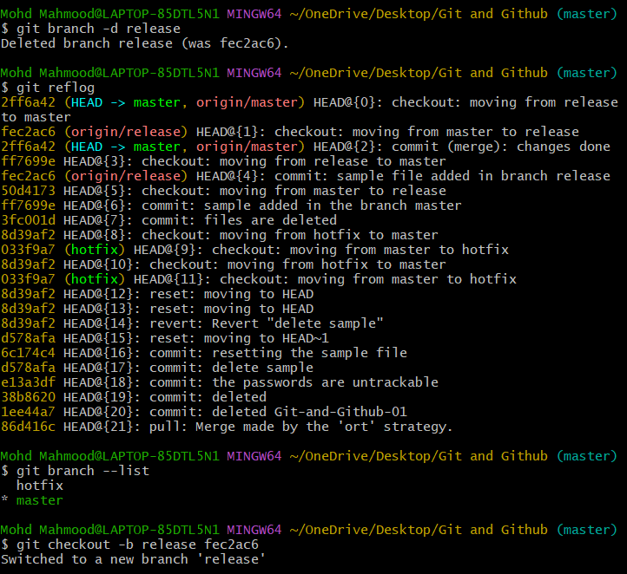
- Delete a local branch and then recover it using the reflog
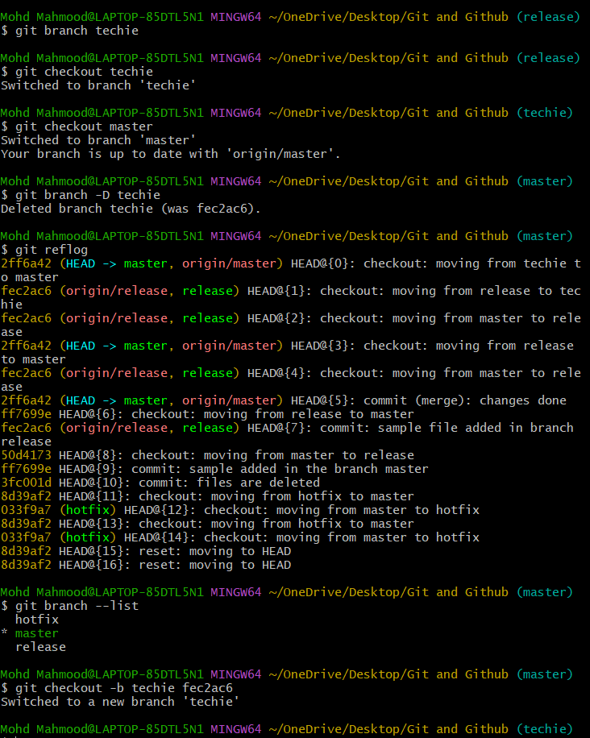
- Undo Wrong Push
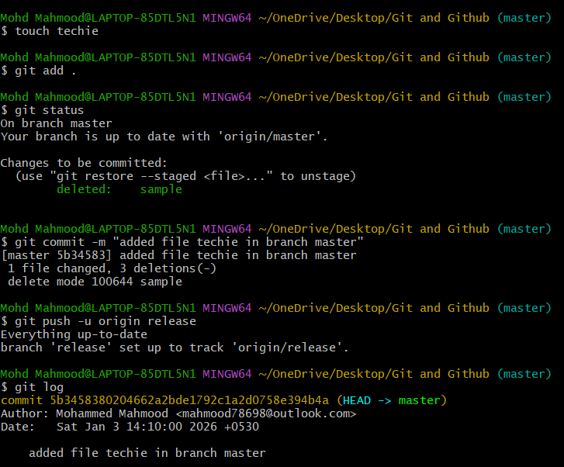
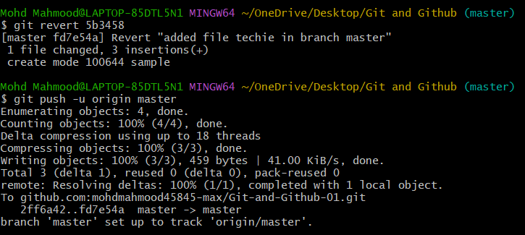
- Push a wrong commit to GITHUB, then undo it with out losing history
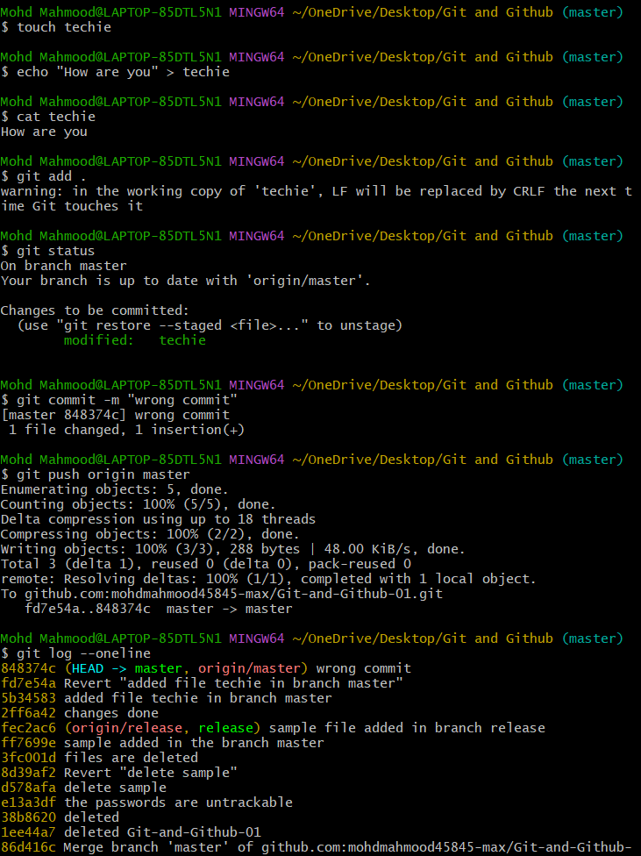
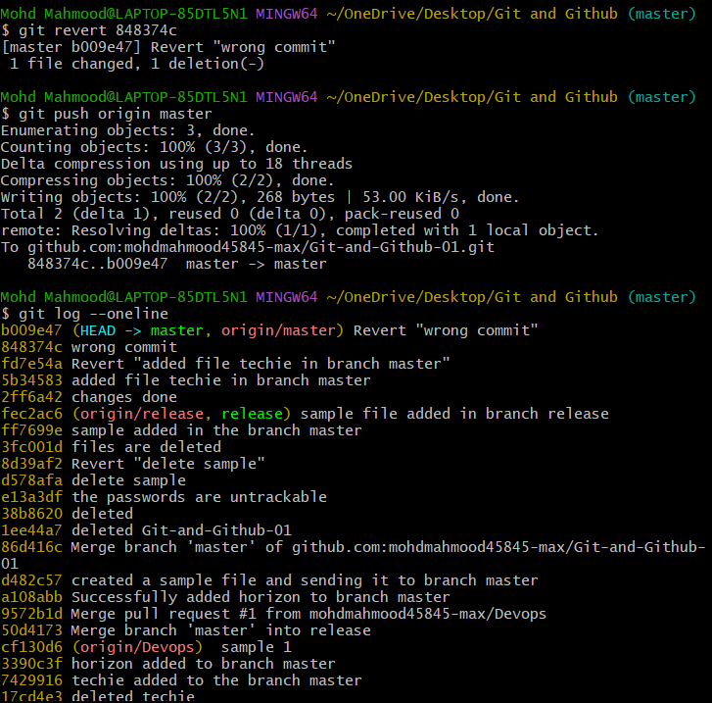
Amend A Commit
- Make a commit, then add a missing file to it using git commit –amend
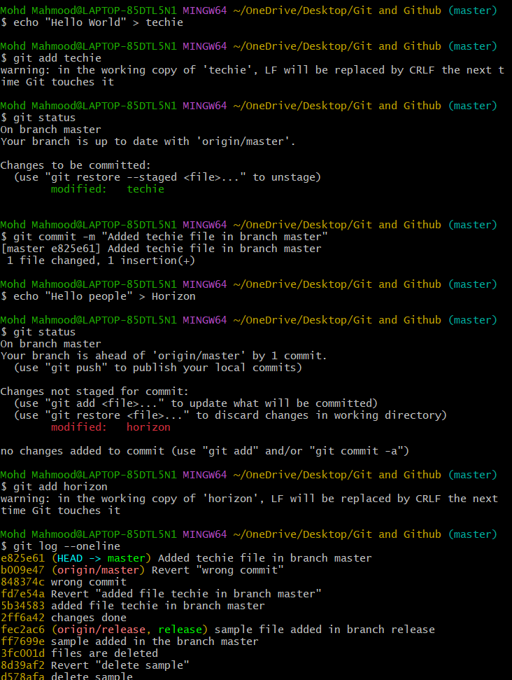
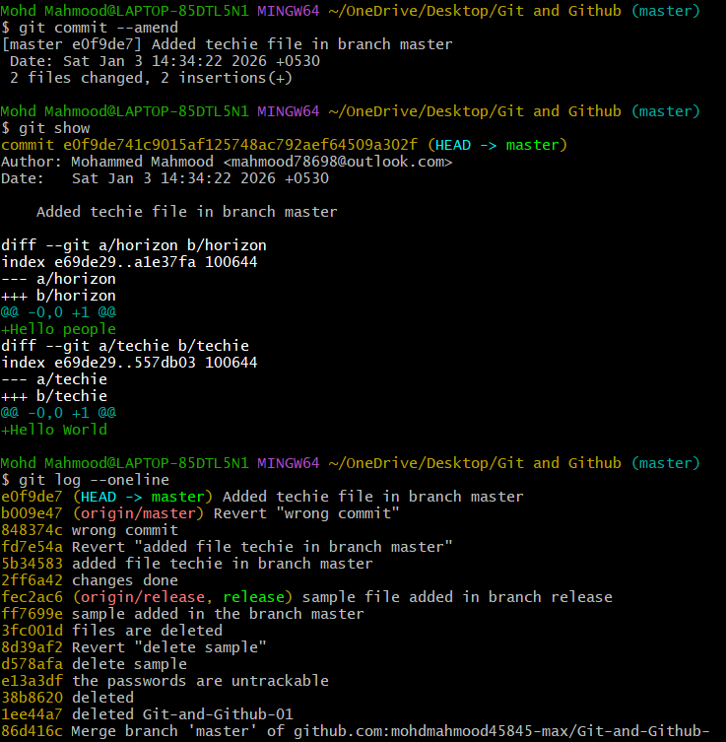
- Cherry pick a commit
cherry pick is used to copy a specific commit from one branch to another
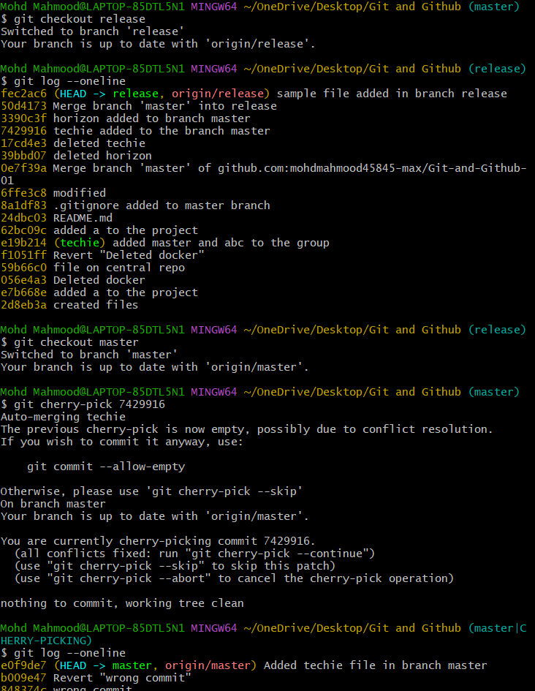
- Take a specific commit from one branch and apply it another branch
Here we can use cherry-pick
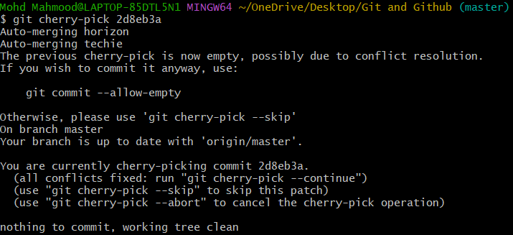
- Interactive Rebase: interactive rebase used to rewrite commit history before sharing it
-Reorder and Squash multiple commits in to a single line commit
git rebase -i HEAD~4
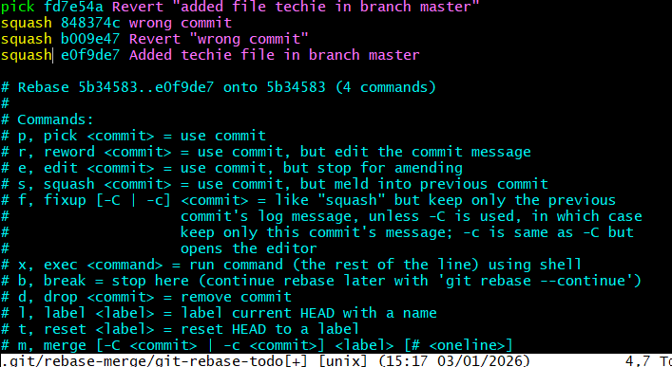
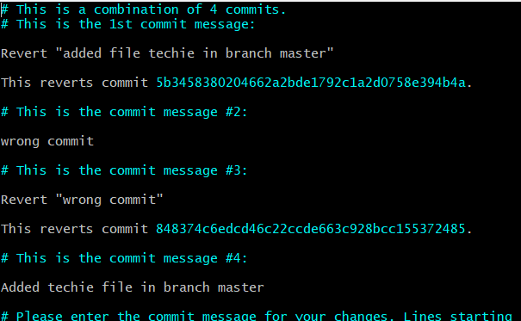
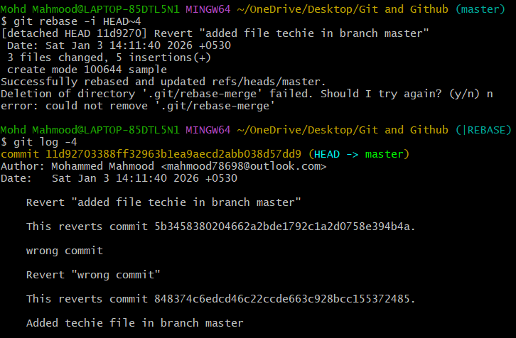
- Tagging and Release: Tags and releases are used to mark important milestones and ship software.
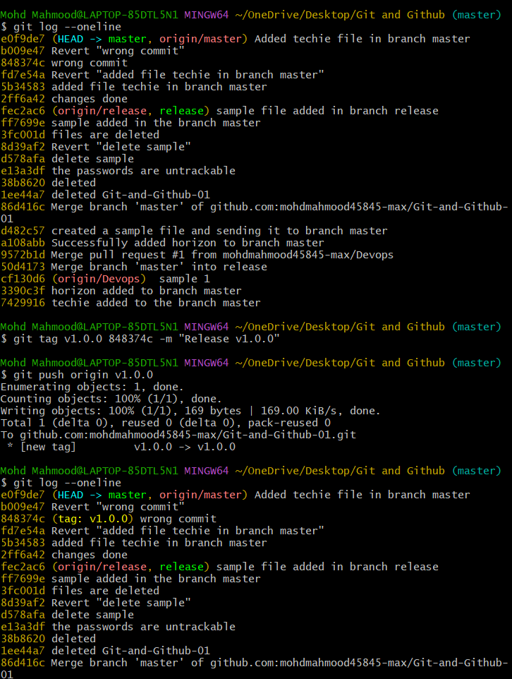
- Create a version tag (v1.0), push it to GitHub, then delete and restore it
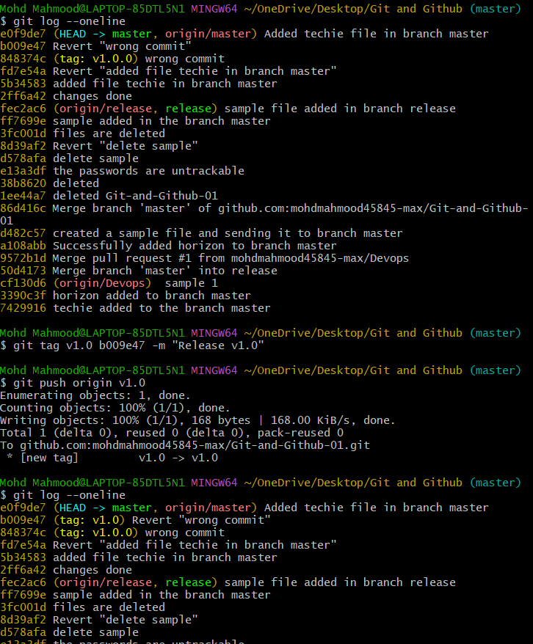
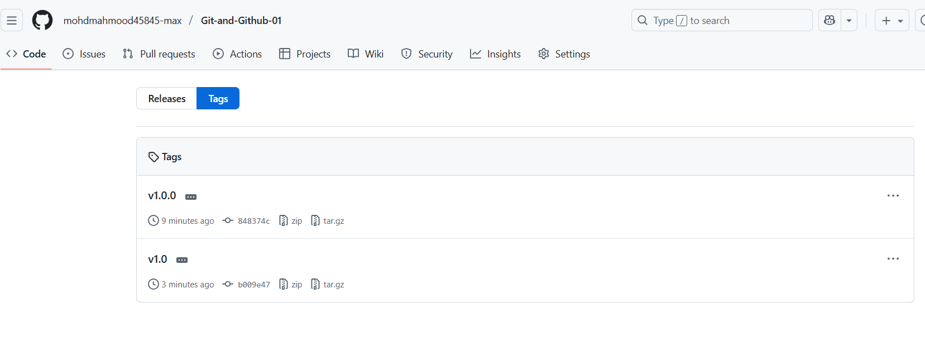
Deleted the tag
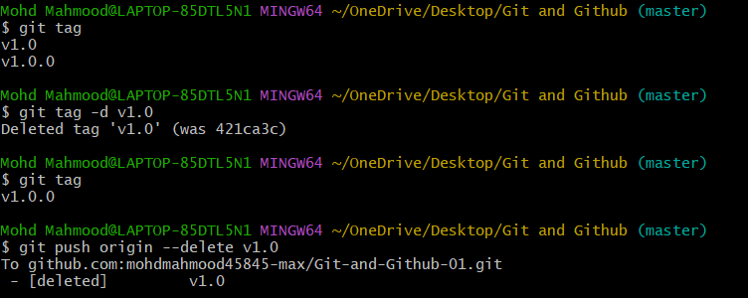
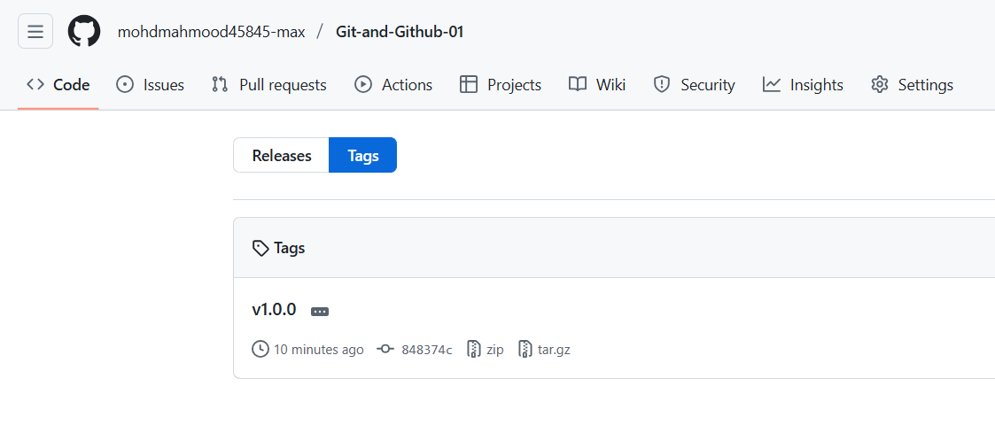
Restored the tag
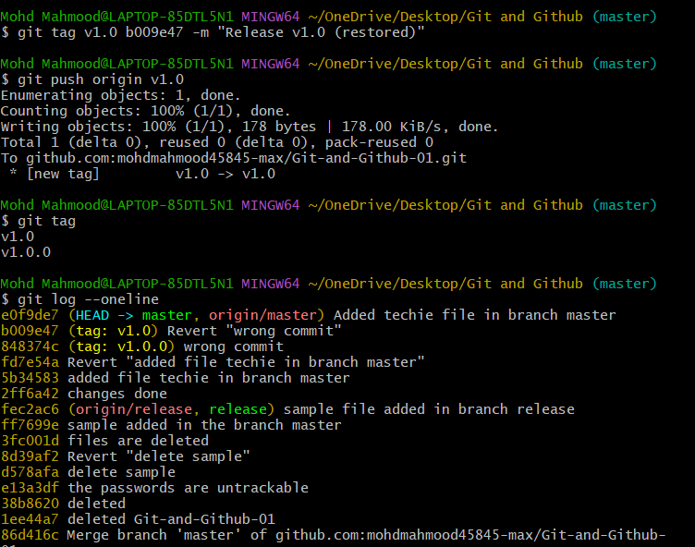
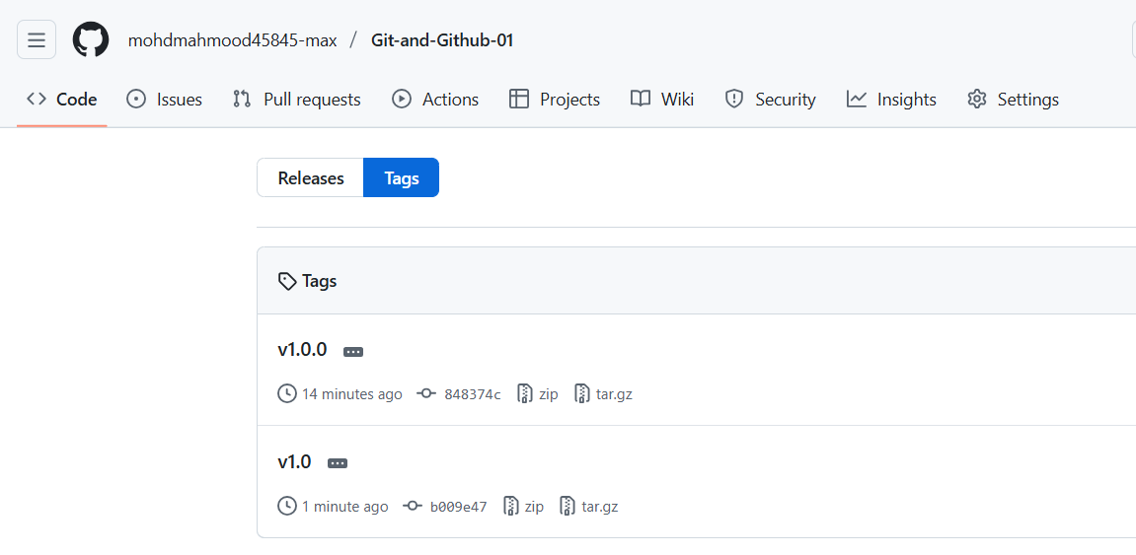
- CLONE WITH SPARSE CHECKOUT
Sparse checkout lets we clone a repository but check out only specific folders/files, not the entire repo. This is very useful for large repositories
- When to Use Sparse Checkout
Repo is very large
You only need one folder/module
Faster clone, less disk usage
Sparse checkout allows checking out only specific files or directories from a Git repository instead of the entire project
- Clone only a subdirectory of a repo using sparse checkout

RESET VS REVERT CHALLENGES
- Demonstrate the difference between git reset --hard and git revert in a repo
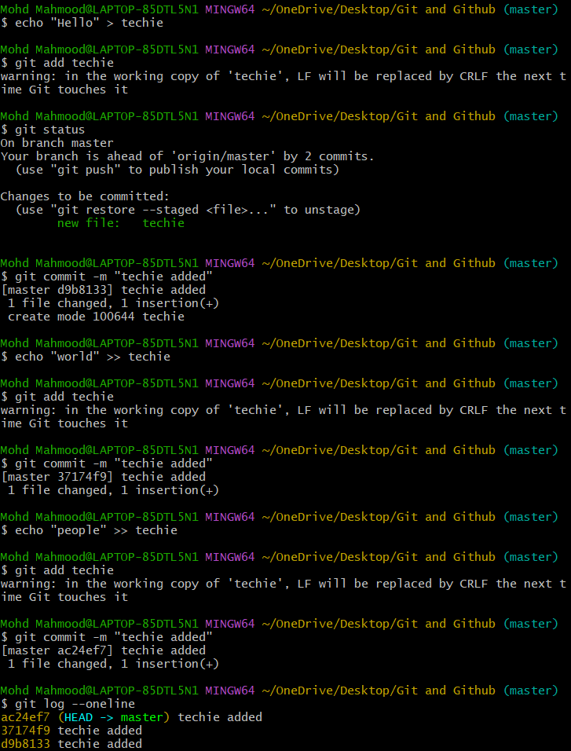
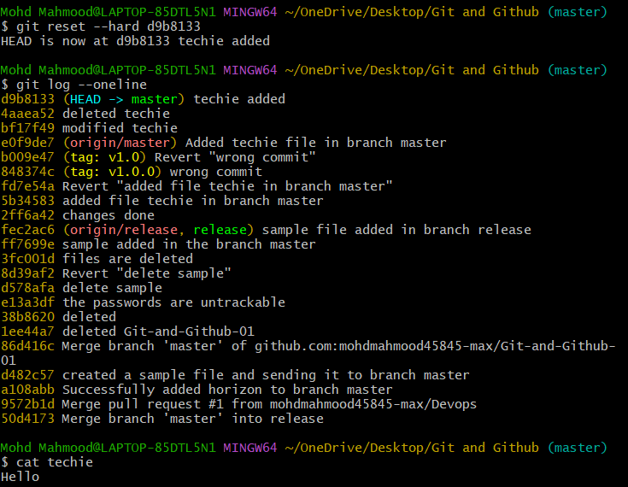
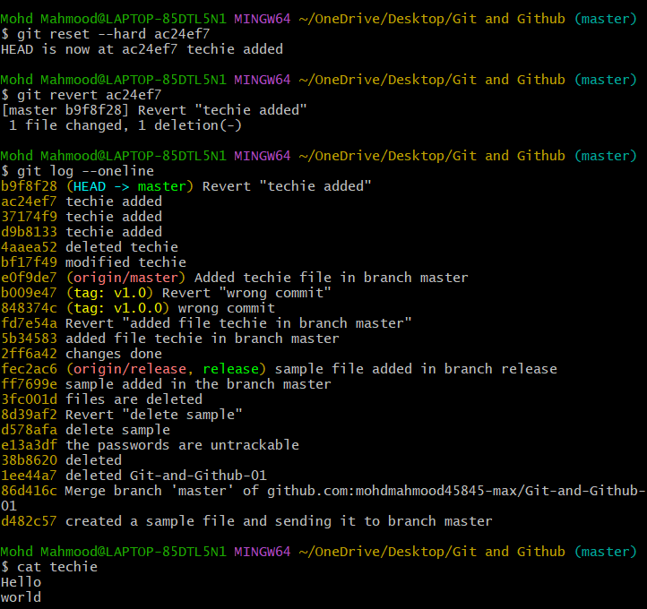
- Detached HEAD Challenge
Checkout a specific commit (detached HEAD state) and create a new branch from it
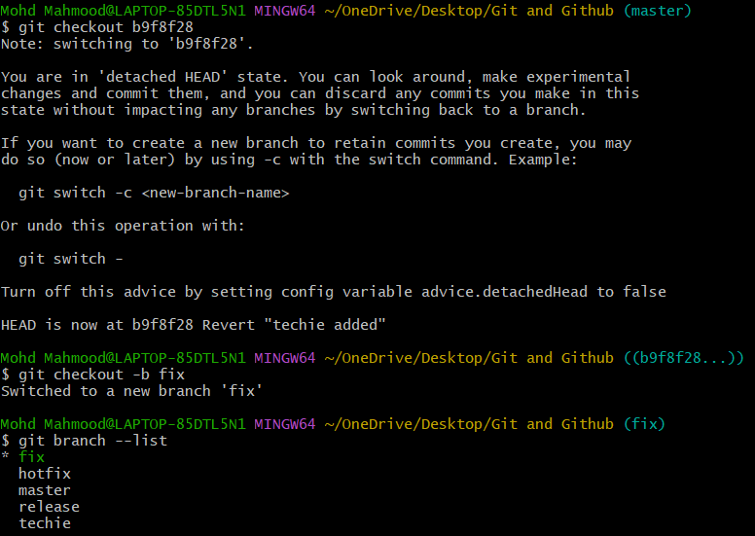
GIT HOOKS CHALLENGE
- Configure a pre-commit hook to reject commits without a message format (e.g., must start with JIRA-XXX)
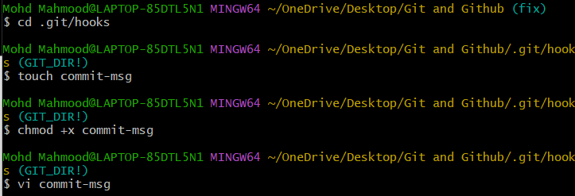
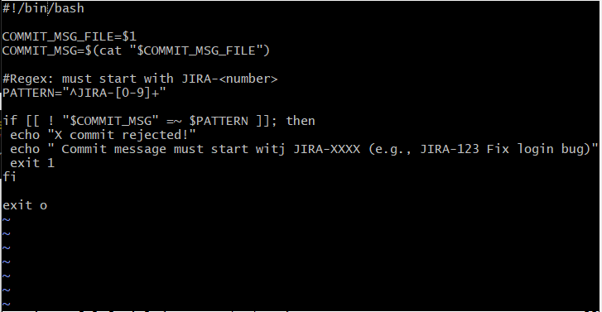
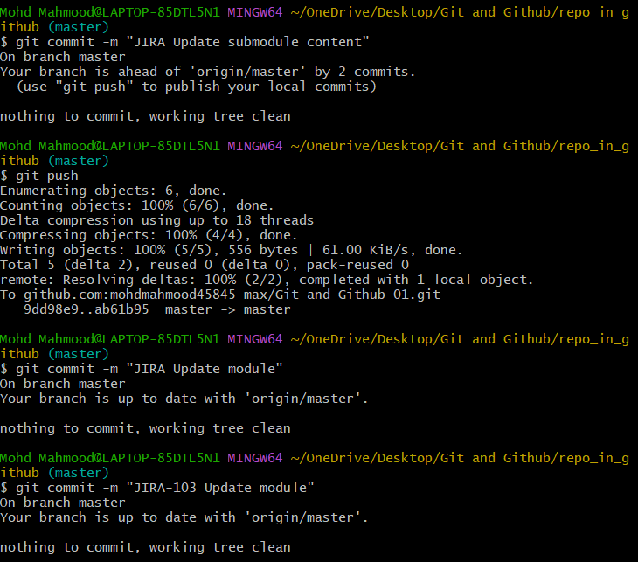

SQUASH MERGE VS REBASE MERGE
- Show the difference between squash merger and rebase merge with evidence
Creating a branch with multiple comments
commit history before merge then squash merge command
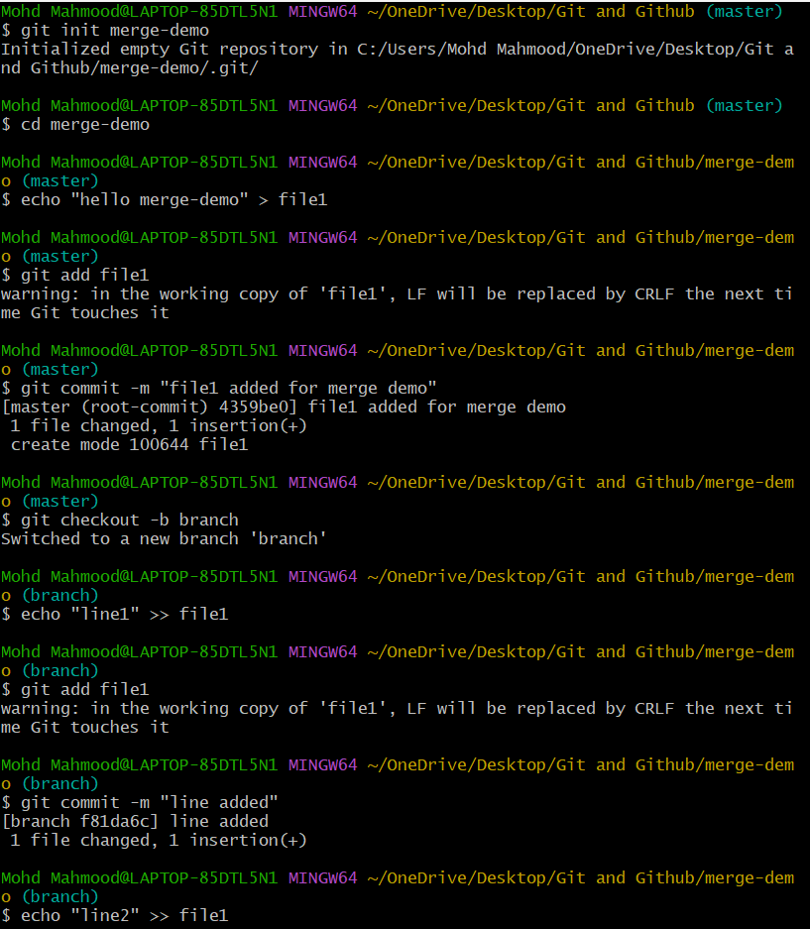
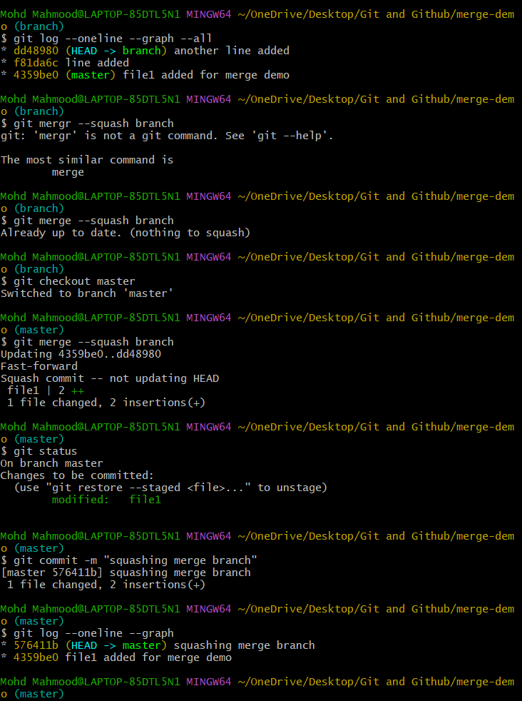
Rebase
rebase master to before squash then rebase branch in to master
merge feature in to master
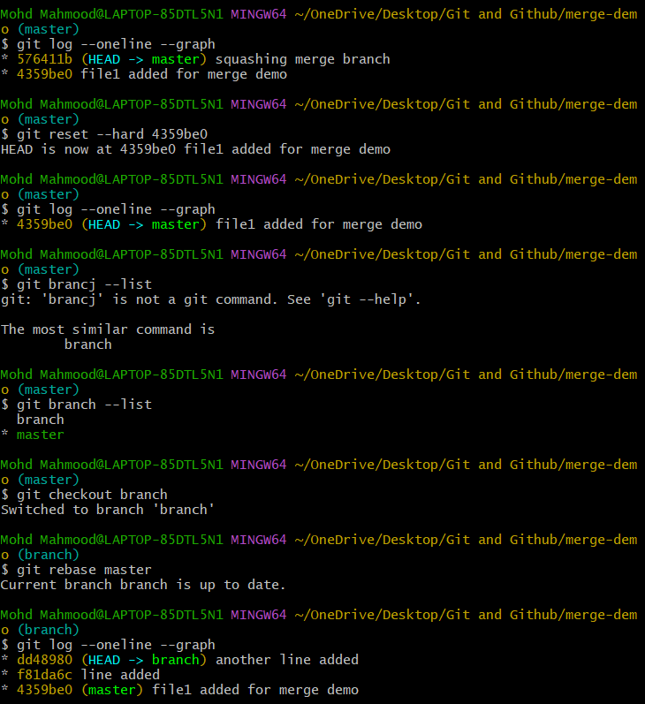
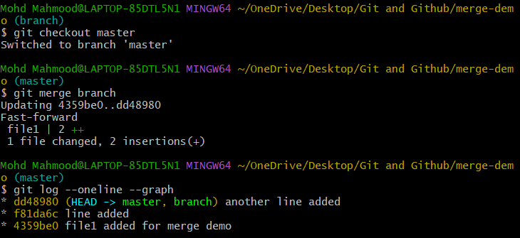
FORK AND PULL REQUEST WORKFLOW
- You don’t have write access to the original repo
You contribute via your own fork
Changes are proposed using a Pull request
Upstream repo – Original project (owner’s repo)
Fork – Your copy of the repo
Local repo – Your machine
Pull request – Request to merge your changes
- Fork a repo, make a change, and submit a pull request to the original repo.
Go to the original repository in GitHub
Fork the Original Repository (GitHub UI)
Go to the original repository on GitHub
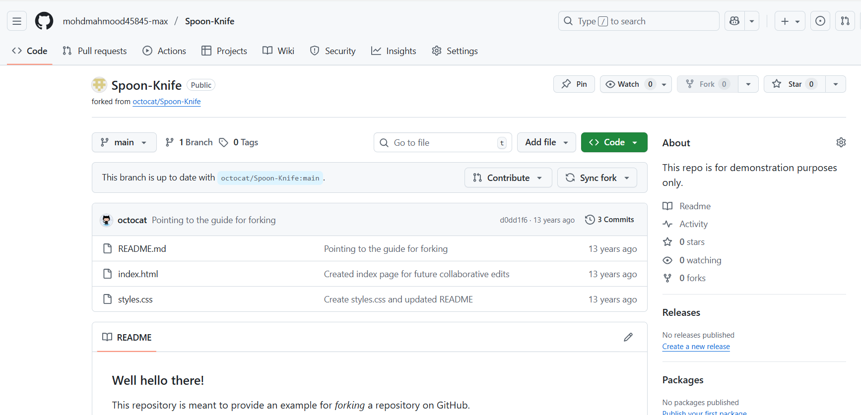
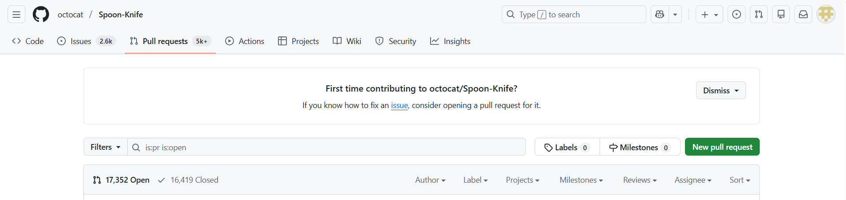
- RECOVER LOST COMMIT
- Commit something, reset hard, and then recover it using git reflog
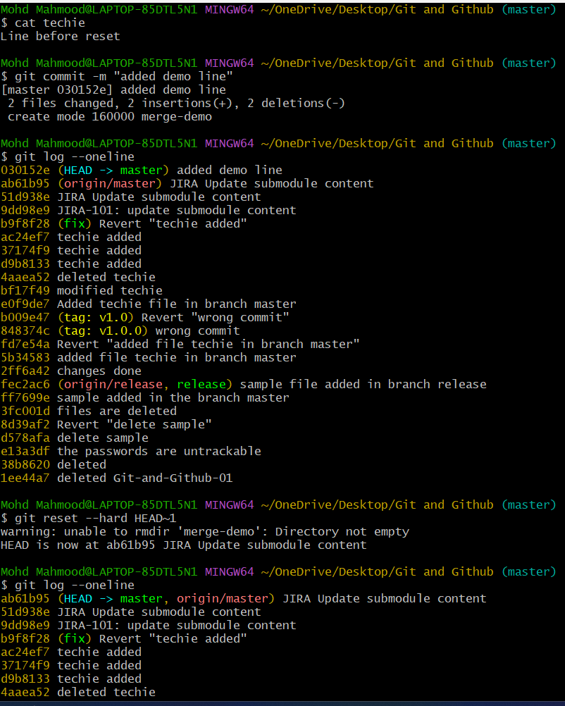
File created and deleted now recover the lost commit using git reflog
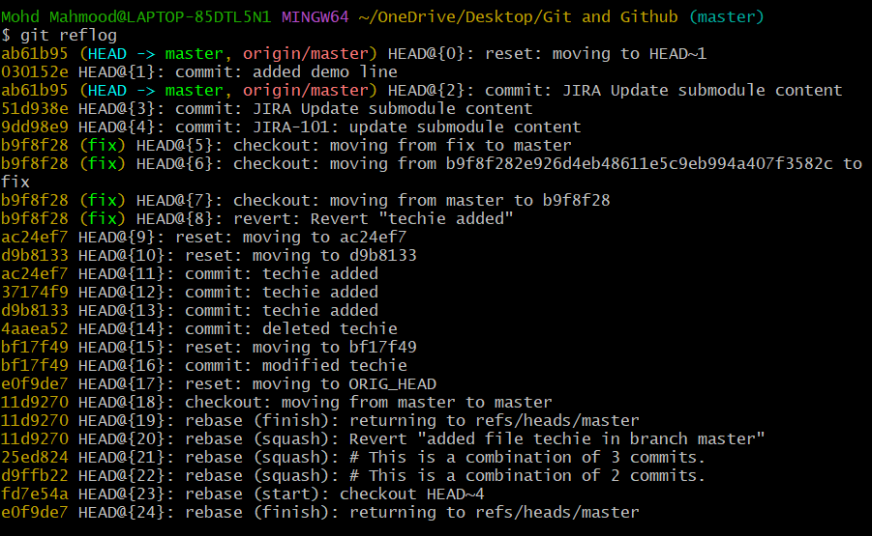
git reset –hard commit id and cat file name then you can see whatever deleted before it gets replaced
